**Data takeout: Facebook (web)**

1. **Log in to Facebook and open your Accounts Center**

Open Facebook and log into your account: <https://www.facebook.com/>.

Once you sign in, click on the following link to access the Accounts Center: <https://accountscenter.facebook.com/>.

1. **Click Your information and permissions**

Click on **Your information and permissions** on the left panel: <https://accountscenter.facebook.com/info_and_permissions>

Then click on **Download your information**.

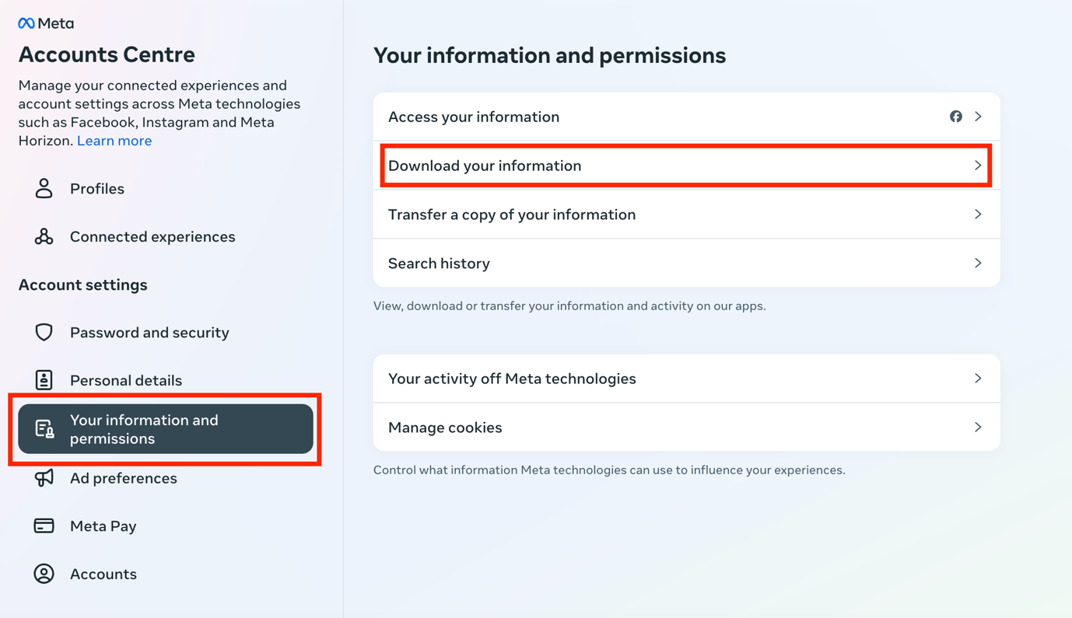

1. **Click Download or transfer information**

Once you click on Download your information, the following page will appear:

Click on **Download or transfer information**.

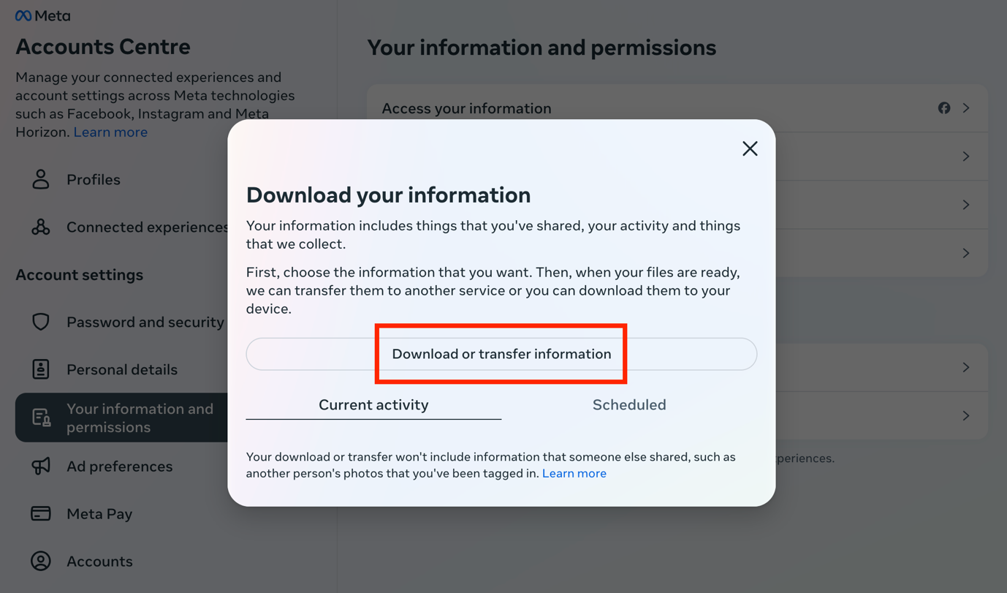

1. **Select the amount of information you would like to download**

Click on **Available information**.

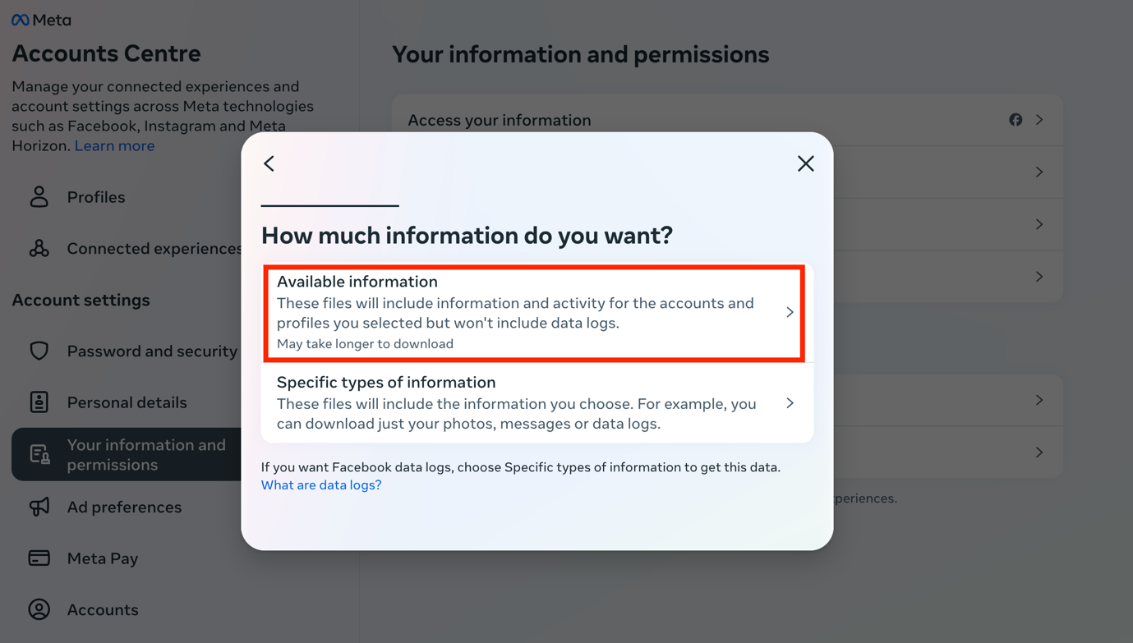

Once you click on Available information, select **Download to device**.

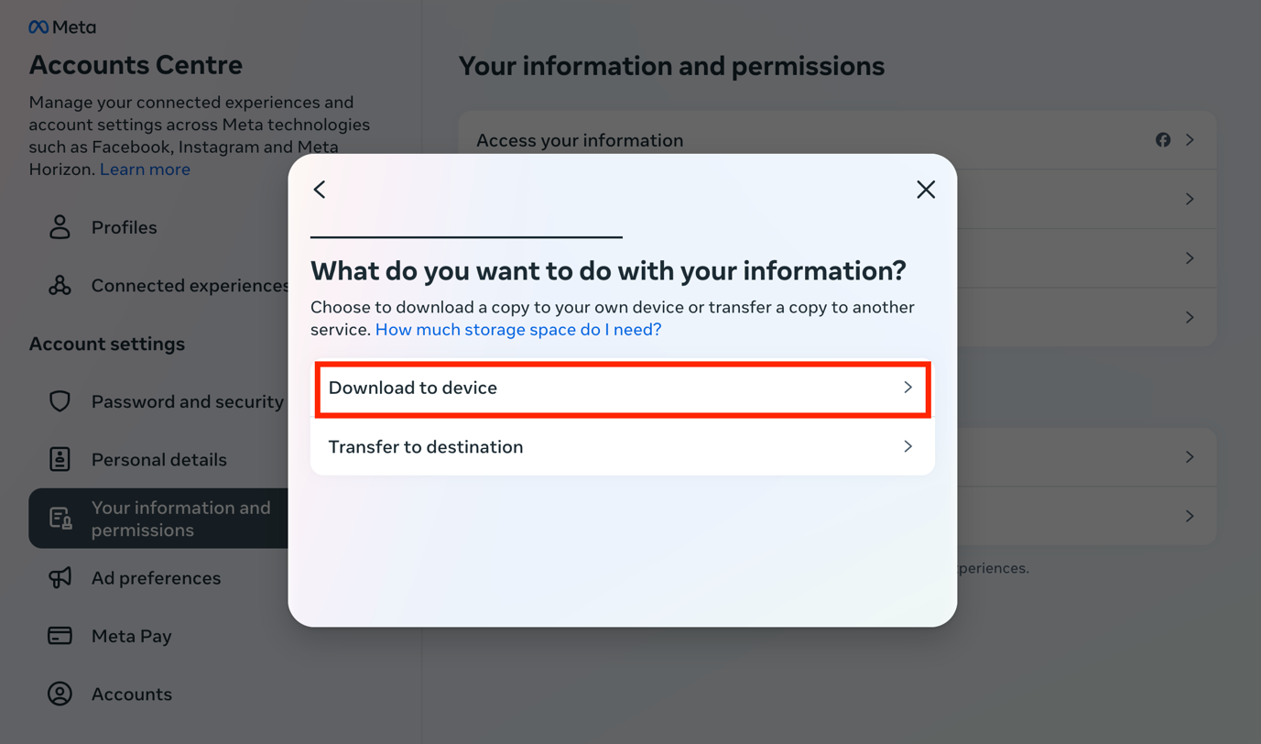

1. **Choose your file options**

The following will appear to select your file options:

Select the **Date range**: All time [*note: Date range can be customised*]

Select who to **notify**: [email address]

Select the **format**:JSON

Select the **media quality**: Medium [*other options: Low/High*]

Then click on **Create files**.

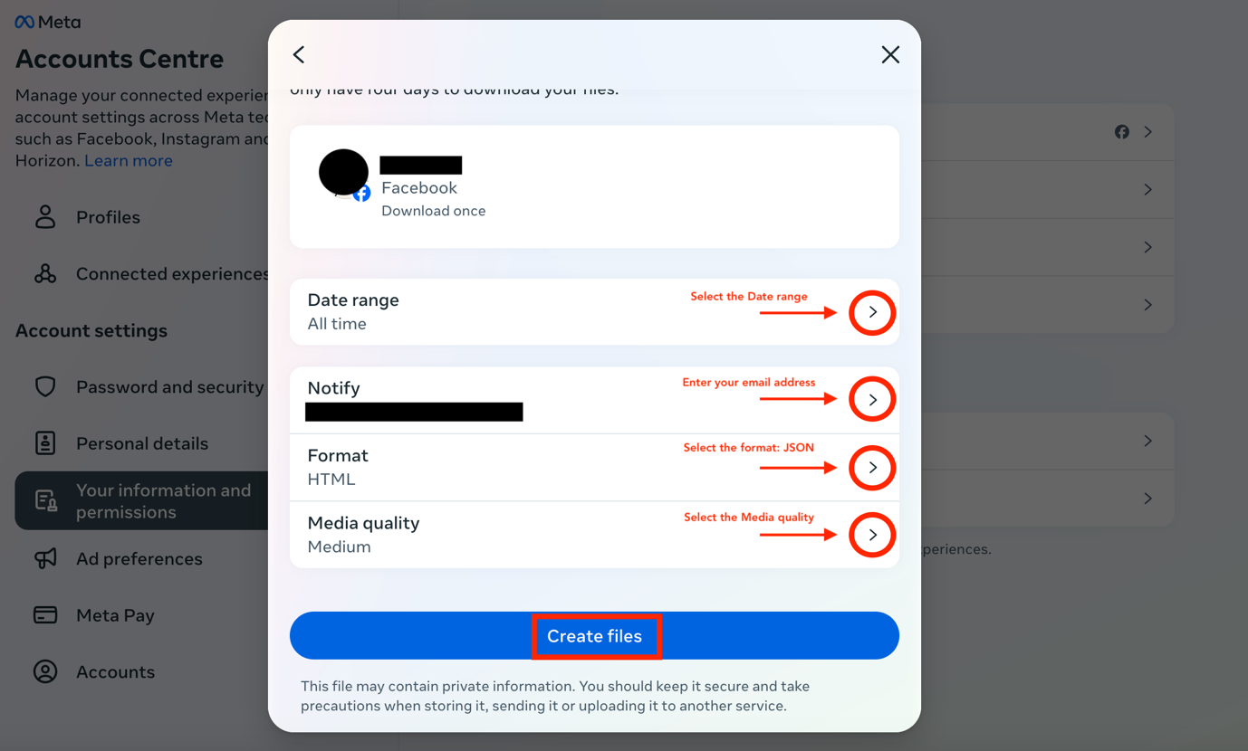

Once you click on **Create files**, this will appear:

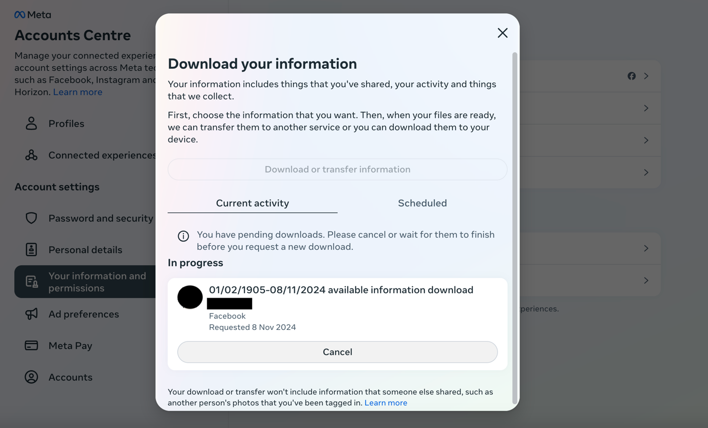

1. **Check your email for the download link**

Meta [notification@facebookmail.com] will send you an email with a download link within 30 minutes [*note: it took 15 with me with the file options I selected*]. Make sure that you are signed in to the email you entered in the previous step. If you have not received the email within a few hours, make sure to check your junk mail folder.

In the email, click **download your information**. You will have to do this within four days of requesting the information, otherwise you will have to request a new download.

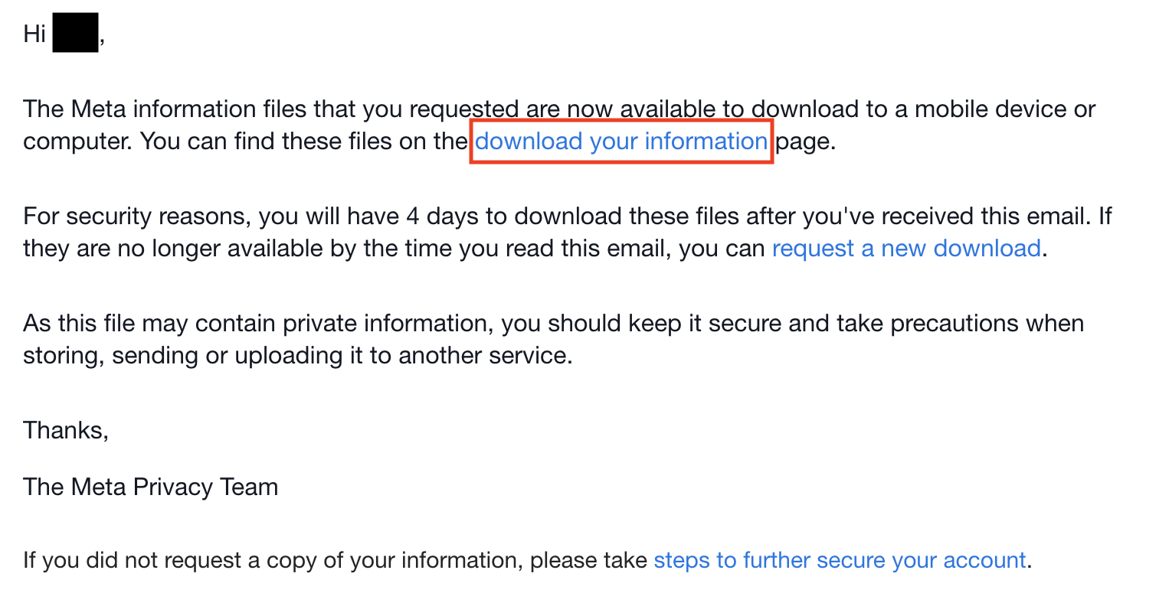

1. **Start downloading the information to your device**

Once you click on the link above, the following page will appear:

Click on **Download** on the bottom left.

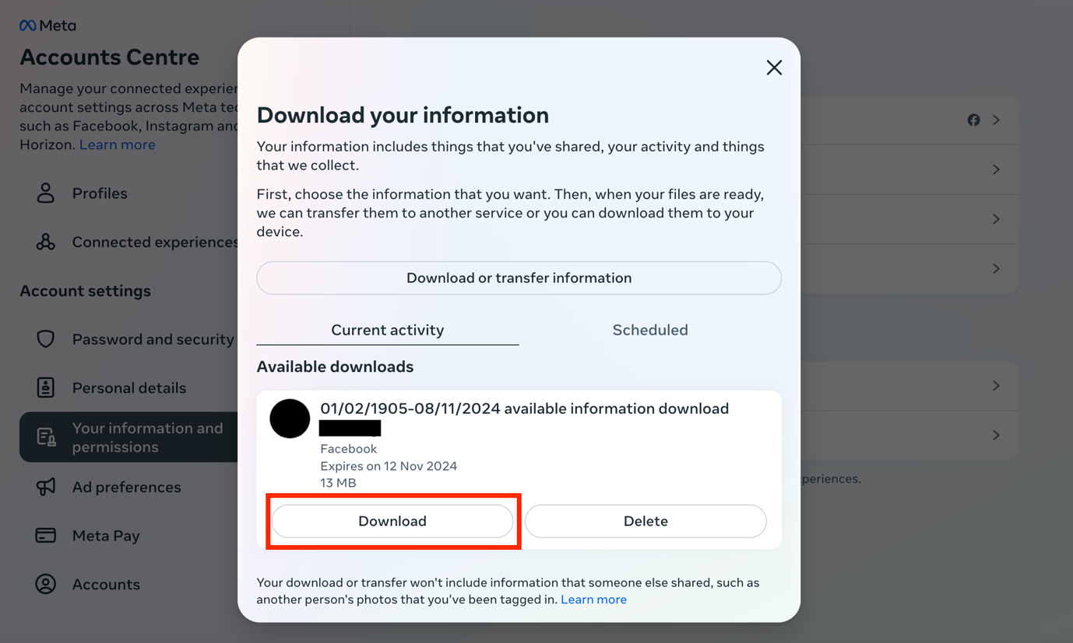

1. **Locate the downloaded file on your device**

The information will be downloaded to your device as a ZIP file and will be saved on your device in the Downloads folder.

**Data takeout: Facebook (IOS)**

1. **Sign in on the Facebook app**

Open the Facebook app and sign in to your account.

1. **Find the Accounts Center**

To request the information, you will have to find the Accounts Center, which is located in the Settings page.

First, click on **Menu** on the bottom right of your screen. Scroll down and click on **Settings & privacy**.

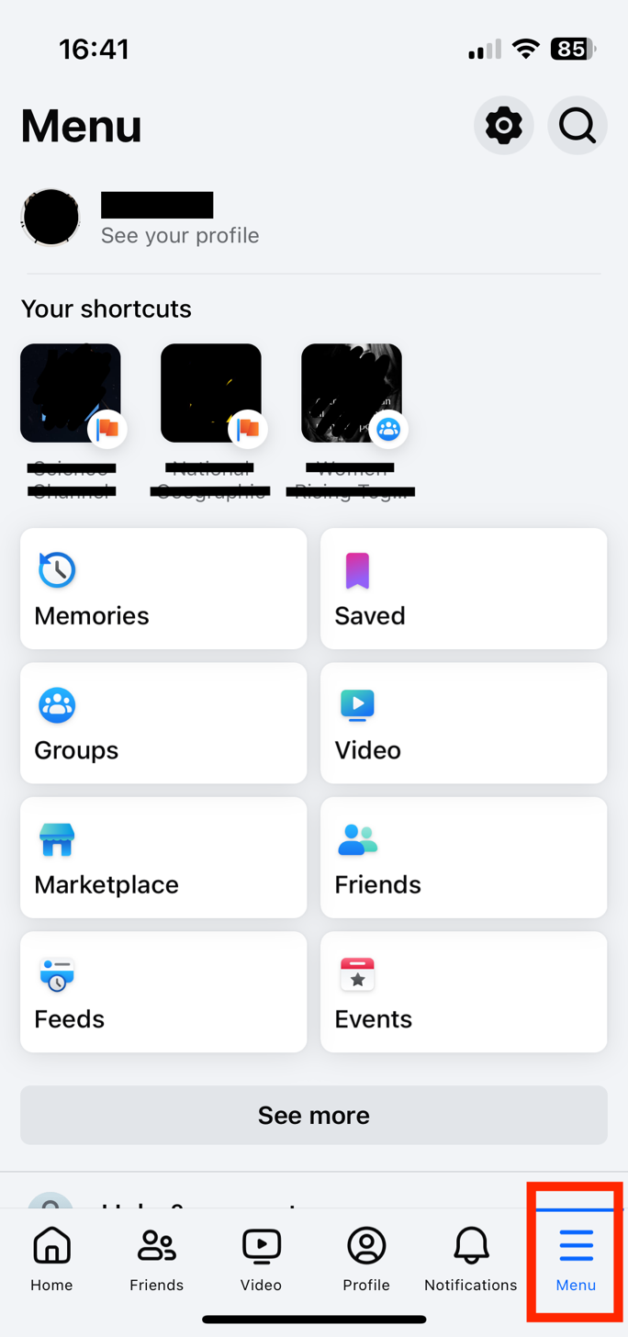 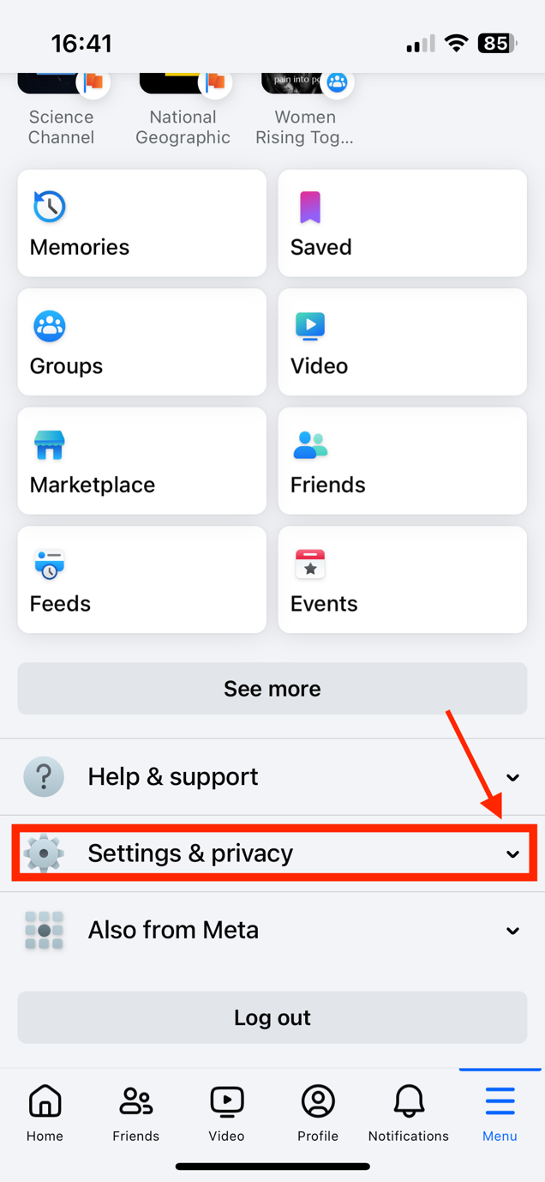

Then click on **Settings**. This will open another page. Click on **See more in Accounts Center.**

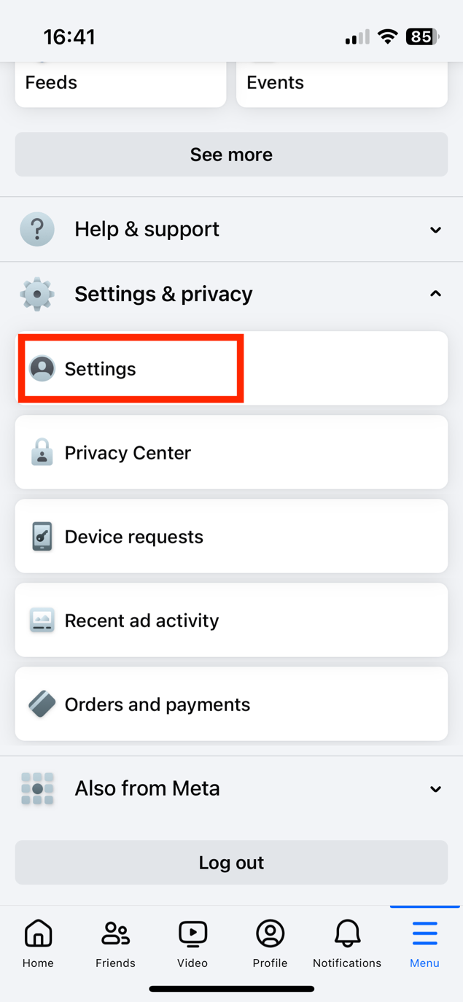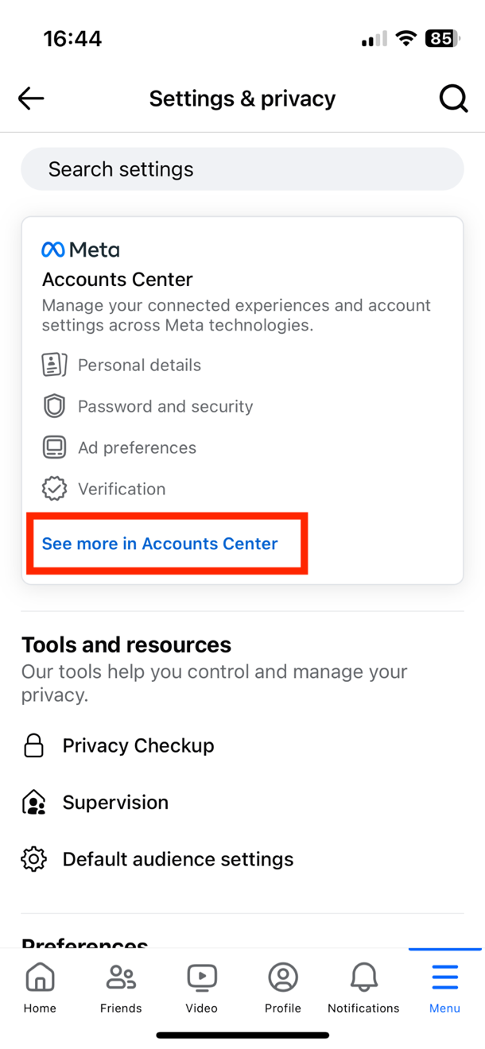

Once you reach the Accounts Center, click on **Your information and permissions**.

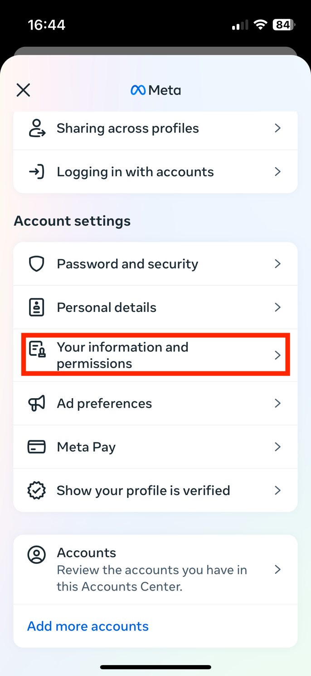

Click on **Download your information**, then on **Download or transfer your information**.

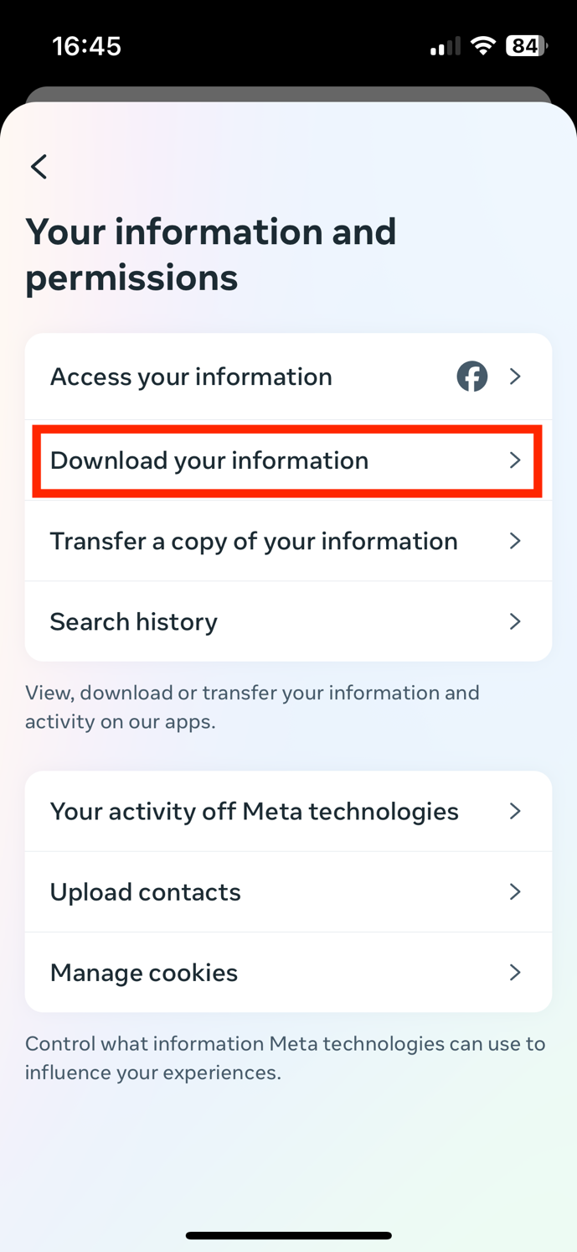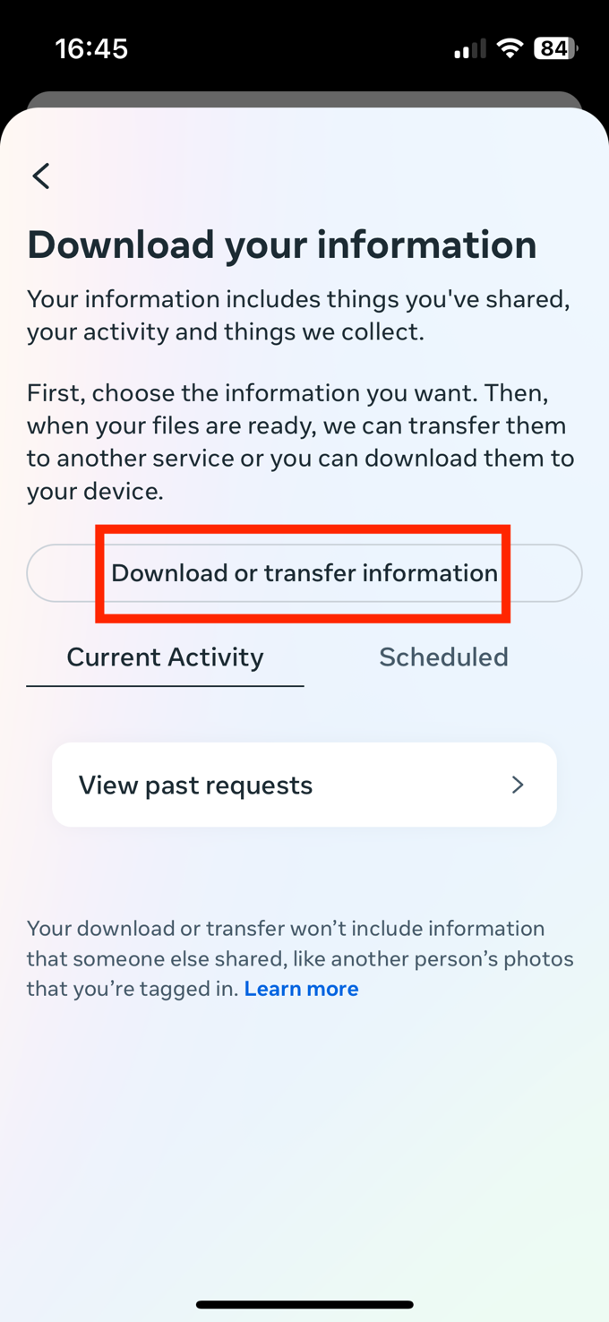

You will be asked how much information you would like to download. Click on **Available information**.

Then click on **Download to device**.

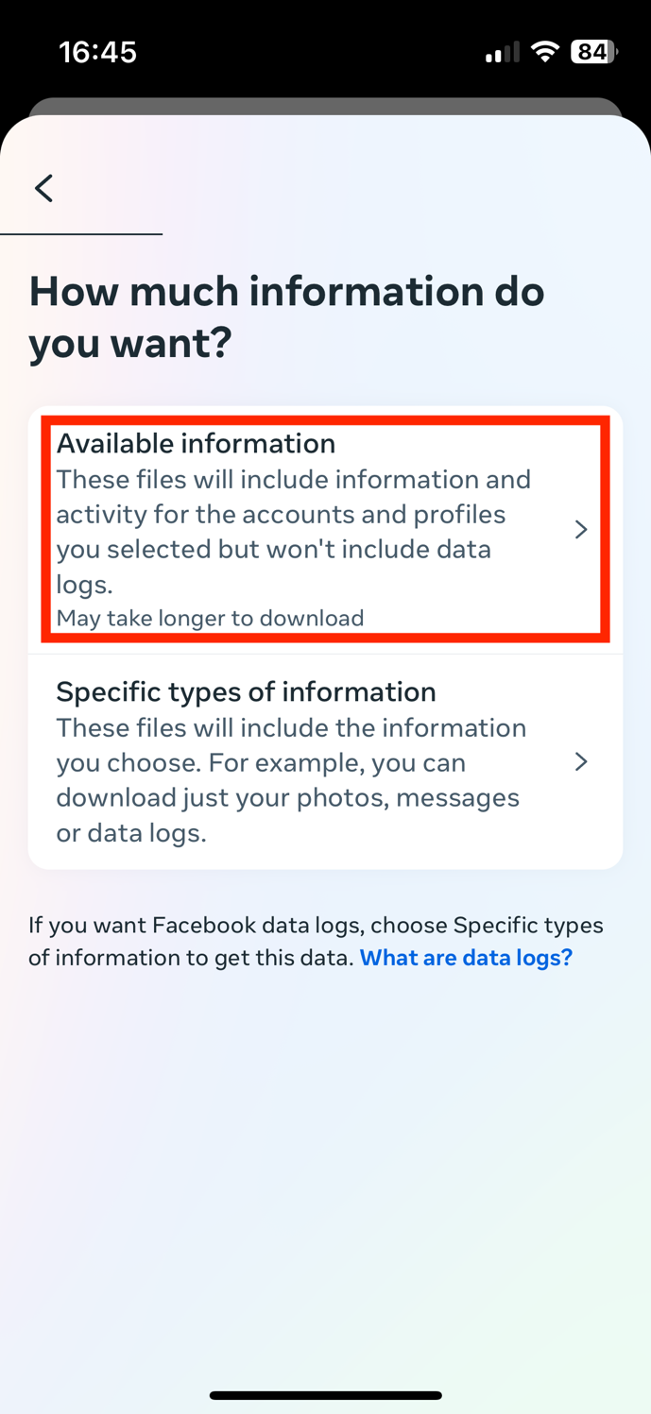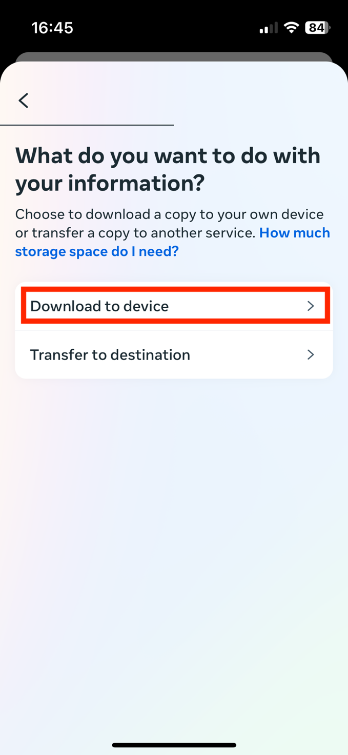

You will then have to specify the date range, who to notify, the format, and the media quality. Select the following:

Date range: All time

Notify: [enter your email]

Format: JSON

Media quality: Medium

Then click on **Create files**.

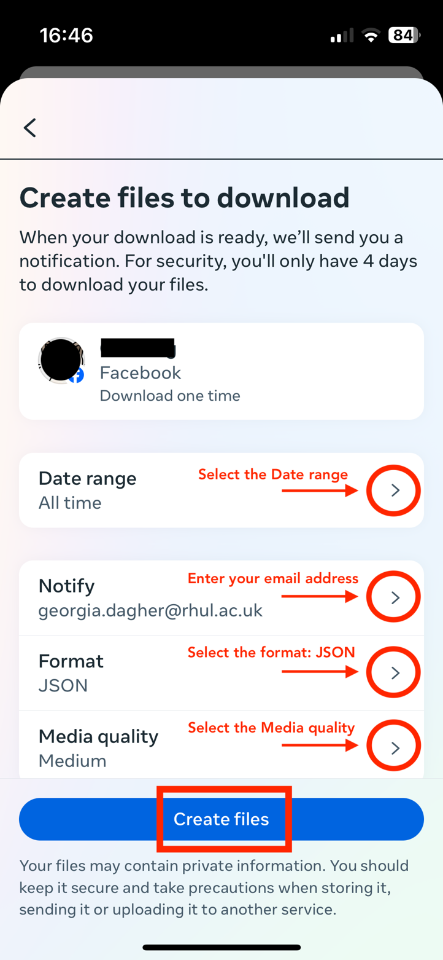

Once you click on Create files, the following page will appear:

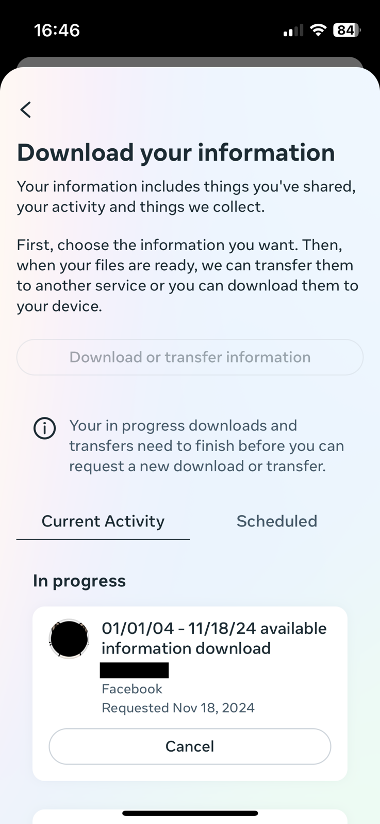

You will then receive an email from Meta [notification@facebookmail.com] with the download link. Make sure that you are signed in to the email you entered in the previous step. If you have not received the email within a few hours (POTENTIALLY DAYS?), make sure to check your junk mail folder.

In the email, click **download your information**. You will have to do this within four days of requesting the information, otherwise you will have to request a new download.

Once you click on download your information, your device will ask you which browser to open the file in.

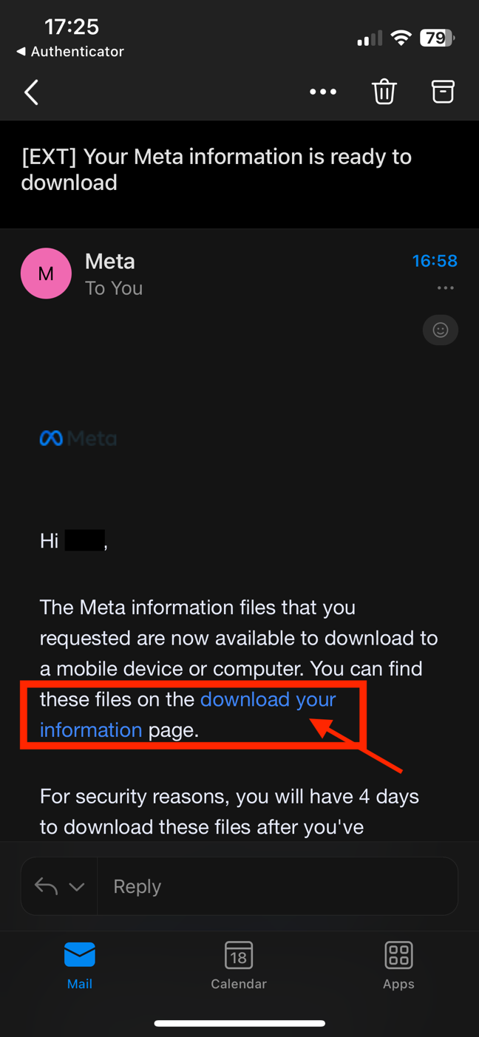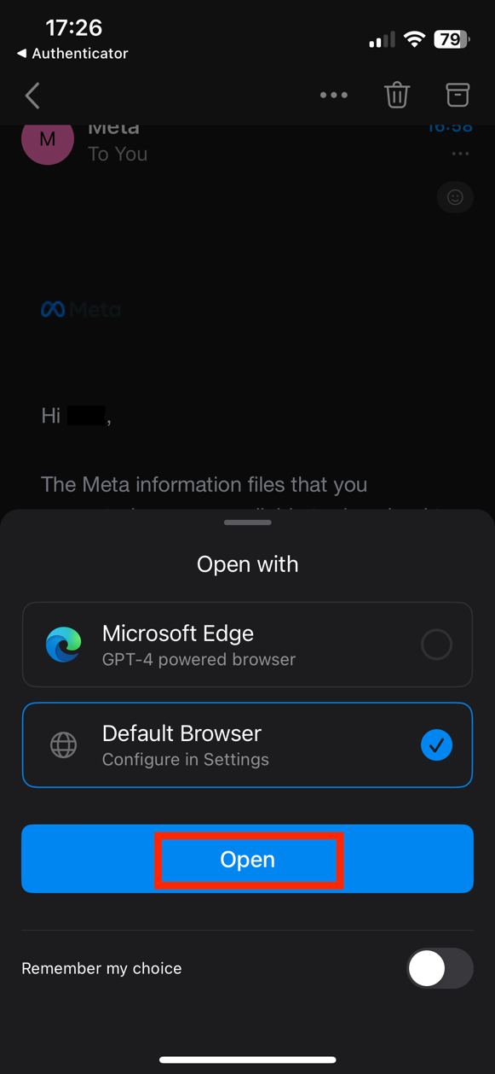

Then open the Facebook app again, and click on **Download**.

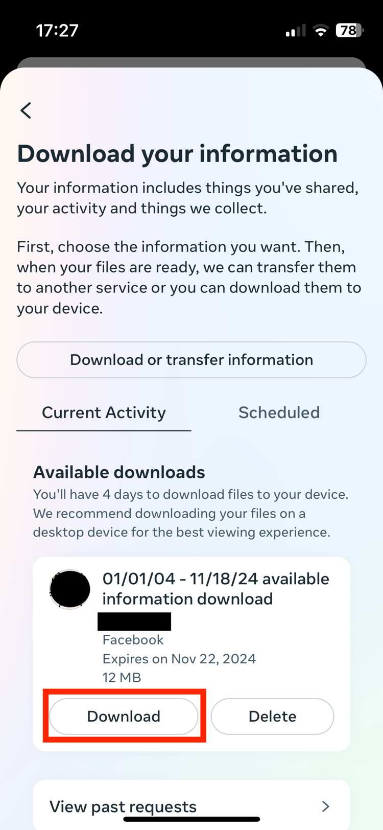

You will be asked to re-enter your Facebook password. Enter your password and click on **Continue**.

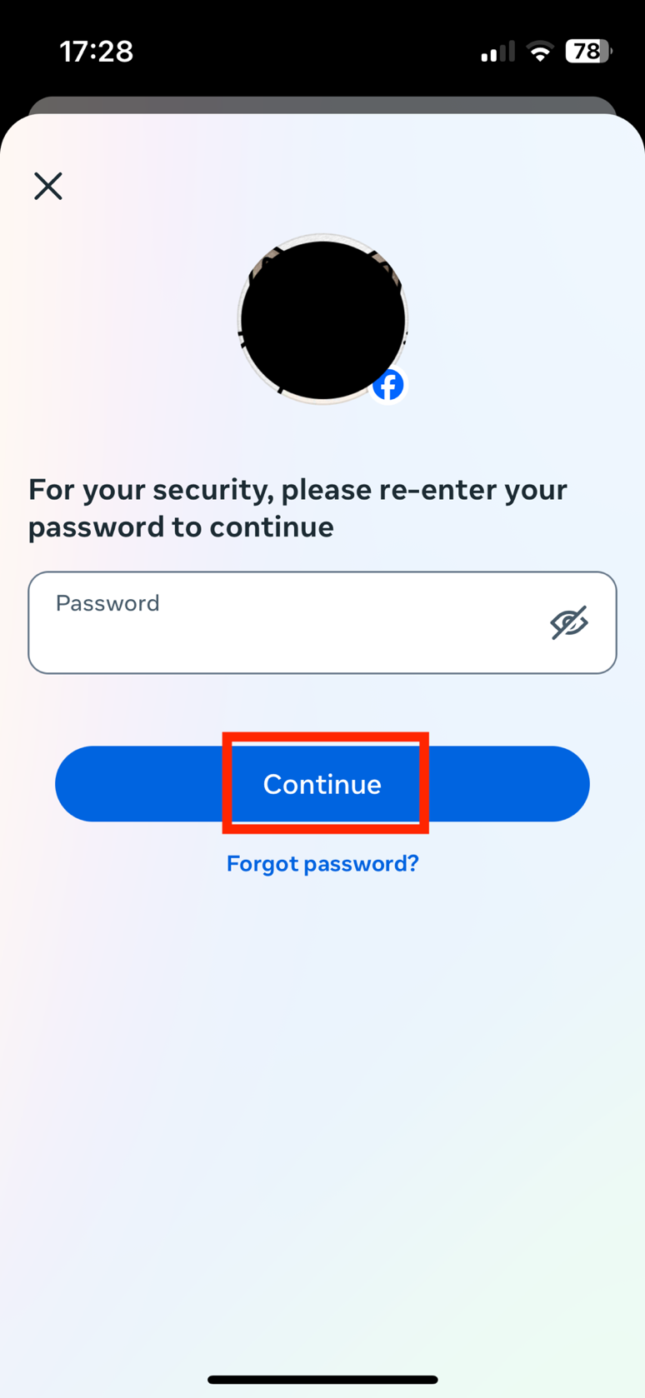

Once you click on Continue, your device browser will automatically open. Click on **Download**.

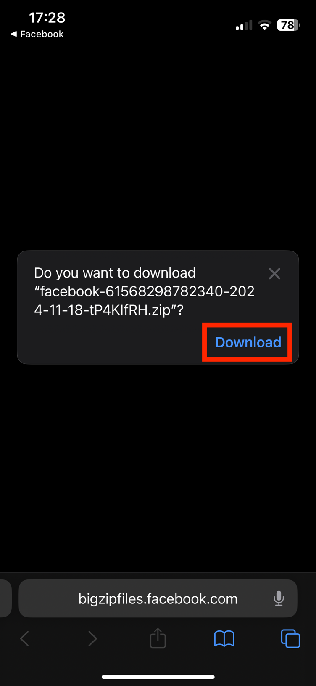

In the browser, click on **Create files**.

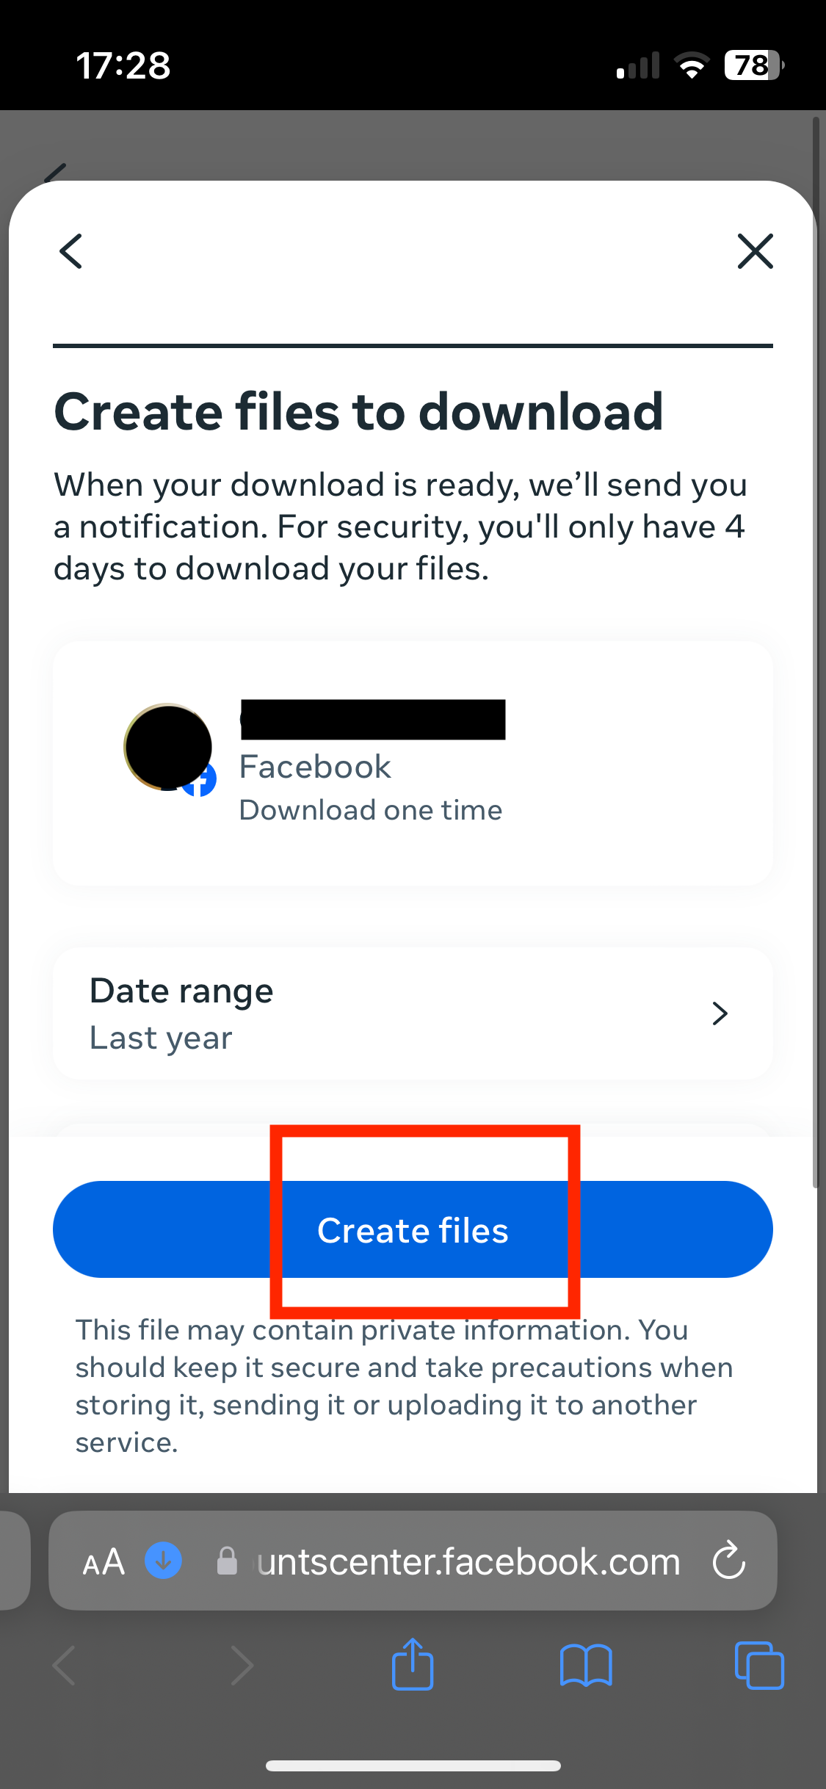

Your download will then start. You can click on the blue arrow on the bottom left, and then Downloads, to make sure that the process has started.

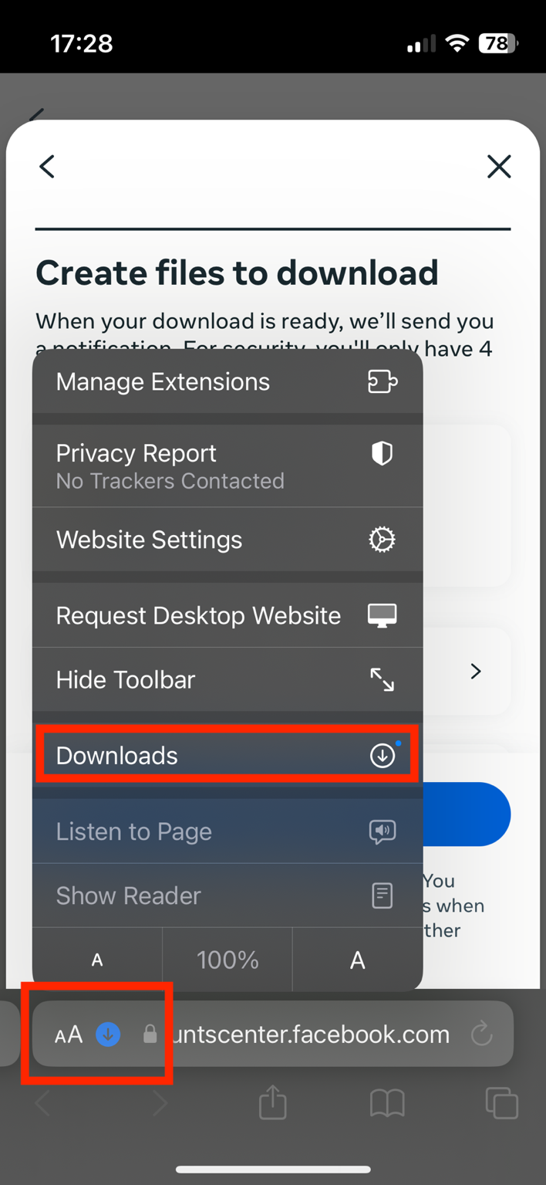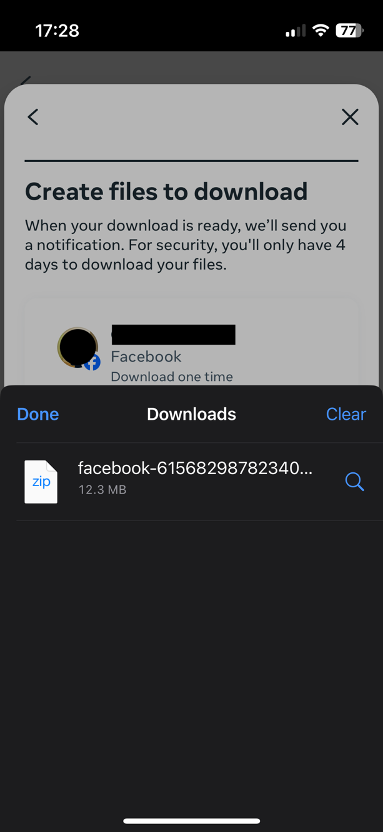

The downloaded information will be a ZIP file. In order to locate it on your device, open your Downloads folder on your device. You can find this through your device’s search bar, or by clicking directly on the ZIP file from your browser.

The Downloads folder should look like this:

